


27490

KP-LAB

Knowledge Practices Laboratory

Integrated Project

Information Society Technologies

D6.6 M33 specification of end-user applications –
<Cass-Query Admin Tool>

Due date of deliverable: 20/11/2008
Actual submission date:

Start date of project: 1.2.2006 Duration: 60 Months

Organisation name of lead contractor for this deliverable: EVTEK

Revision [1.0]

Project co-funded by the European Commission within the Sixth Framework Programme
(2002-2006)
Dissemination Level
PU | Public | PU
PP | Restricted to other programme participants (including the Commission Services)
RE | Restricted to a group specified by the consortium (including the Commission Services)
CO | Confidential, only for members of the consortium (including the Commission Services)
Contributors:
Name | Partner organisation | Email

Version history:
Version | Date | Author(s) | Description

Table of Contents

1 Table of Contents 2
1 Introduction 4
1.1 Purpose 4
1.2 Scope of the software 4
1.3 Roadmap of the tool 4
1.4 What is new in this version? 4
1.5 Definitions 4
2 User requirements 4
2.1 Relationship with KP-Lab research studies 4
2.2 Driving Objectives and High-Level Requirements 5
2.3 System usage scenarios 5
2.4 Use cases 5
3 Technical design 5
3.1 Software architecture 5
3.2 GUI 5
3.3 Front end services 6
3.4 Collaboration with other tools 6
4 References 6

Introduction

Purpose

This document describes the functionality of the Cass-Query Admin Tool.

Scope of the software
The CASS-query tool is meant for researchers investigating various actors’ experiences, thoughts and perceptions in daily activity contexts. The CASS-query tool helps to expand knowledge about how various actors thoughts and feelings coincide with contextual characteristics and events related to their daily activities. Knowledge created by the tool can be used as feedback for the participants of the follow-ups conducted by mean of it. This feedback in turn can serve as auxiliary information in reflecting and reorganizing the participants’ activities.

The CASS-Query tool is composed of two different sets of functionalities, Cass-Query client and Cass-Query Admin tools. The Cass-Query client tool is running in the mobile telephone. For the end-user, it is principally the queries that the participant gets in their mobile application. The Cass-Query Admin tools is a server database, which deals with transmitting and storing data. The Admin tool, which is operated through an administration website, is for administrating researches. There researchers can create researches and enter queries and participants to them. Everything to set up a research is done in the Admin tool. Researches are linked to the mobile application through the mobile phones Bluetooth identifier. The Admin tool takes care that the respondents get the correct query to their mobile phone.

Cass-Q Client tool is a Java-application for collecting process- and context-sensitive data. The system is implemented on 3G mobile devices (e.g., Nokia E70) with Symbian operating system, MP3, video, GPS, WLAN.

The CASS system provides generalisable tools in open-source terms (i.e., adaptable and free of charge) that can, in a flexible way, be tailored and elaborated for particular needs and requirements of researchers and users.

Roadmap of the tool
Old Cass-Query version (M20)
- Queries created with the CASS-Admin tool (XML-editor)
- Queries are customizable to each user
- User opens the application, which retrieves a preset query from the server
- Queries can contain different questions with different types of responses: open text, Likert scale, picture, video, audio recording
- Responses are returned to server database once the participant indicates it is completed
- Data can be transformed statistics software SPSS

Admin functionalities:
Admin is a www-based administration tool, which enables
- Entering participant info (name, ID, contact info, projects, etc) to database
- Downloading queries to server database
- Xml-editor for creating queries, including instructions for using it.
- Monitoring the accumulation of data in real-time
- Searching and browsing participant info and data

Current version
Admin currently enables:
- .Creating researches with three different ways of data collecting
- Creating queries to researches
- Editor for creating questions to queries, editor also enables to copy existing questions
- Inserting participants, researchers and research administrators to researches.
- Managing user rights in a research
- Setting mobile phone Bluetooth identifiers to participants
- Downloading data by whole research or by a specific query
- Downloading pictures, videos and sound-clips in a zip-archive
- Watching pictures and videos in browser.
- Editing researches, queries, questions, users etc,
- Downloading Word-document containing information of research or query

What is new in this version?
In current version of Cass-Query Admin tool everything can be done by a graphical user interface and managing a research is made much easier. There are two data collection methods more which enable to make more specific researches. Queries and questions are made by an editor and users don’t have to know any XML (Extensible Markup Language), so no XML-documents are uploaded to server, it is now generated by the editor.

Managing participants is easier, also creating them to a research is easier because they are not created and inserted to researches one by one. Current Admin tool has roles for users which previous didn’t.

Data can be downloaded in Excel-documents and information of researches in Word-documents. All pictures, videos and sound-clips can be watched in browser, downloaded separately or all in one zip-archive.

Definitions
Cass client - Java-application in mobile phone used to answer queries
Cass admin - Administration website to manage researches and users

User requirements

Relationship with KP-Lab research studies
<Relationship with the pedagogical studies that the tool is studied in. The pedagogical studies are described in the Annex 1 of the D3.2 (page 17). The final version of D3.2 is available at:
http://www.kp-lab.org/intranet/work-packages/wp3/deliverables/d3-2/D3.2.2-final.doc/view
>

Driving Objectives and High-Level Requirements
<Reference to the DOs and HLRs relevant for the tool.
DOs and HLRs are documented in the D2..4 that can be found in the following Plone folder: http://www.kp-lab.org/intranet/work-packages/wp2/deliverable-2-4-driving-objectives-and-high-level-requirements-for-kp-lab-technologies-m32/
As of writing this, version 0.4 is the latest and the Dos and HLRs presented in it are final and can be referred to in the specifications.
>

System usage scenarios
<An overview of the System Usage Scenarios for the tool by referring to the SUS document, which you should find in the tool’s WK folder in Plone within folder:
http://www.kp-lab.org/intranet/design-teams
If it is not there, contact your WK leader.
>

Use cases
<Use the template available at:
http://www.kp-lab.org/intranet/design-teams/common-info/Templates-for-Requirementsdocumentation-v1.doc/view

An example (SMAT) can be found at:
http://www.kp-lab.org/intranet/design-teams/wk-multimedia-annotation/smat-3.0/SMAT_specsJuly2008_2.doc/view
>

Technical design
Note: You may leave this part out if the tool is not yet at the design phase.

Software architecture
The Cass-Query Architecture is illustrated in Figure 1. The architecture figure is composed of three separate parts: the client side, the server side and the data storage. The client side is composed of the administration website and from the Cass client Java-application. The server side has the business logic for the administration website and also for the Cass client. The third part is the database where all data of researches, users and collected data is stored. Data storage also keeps track of participants query answering.
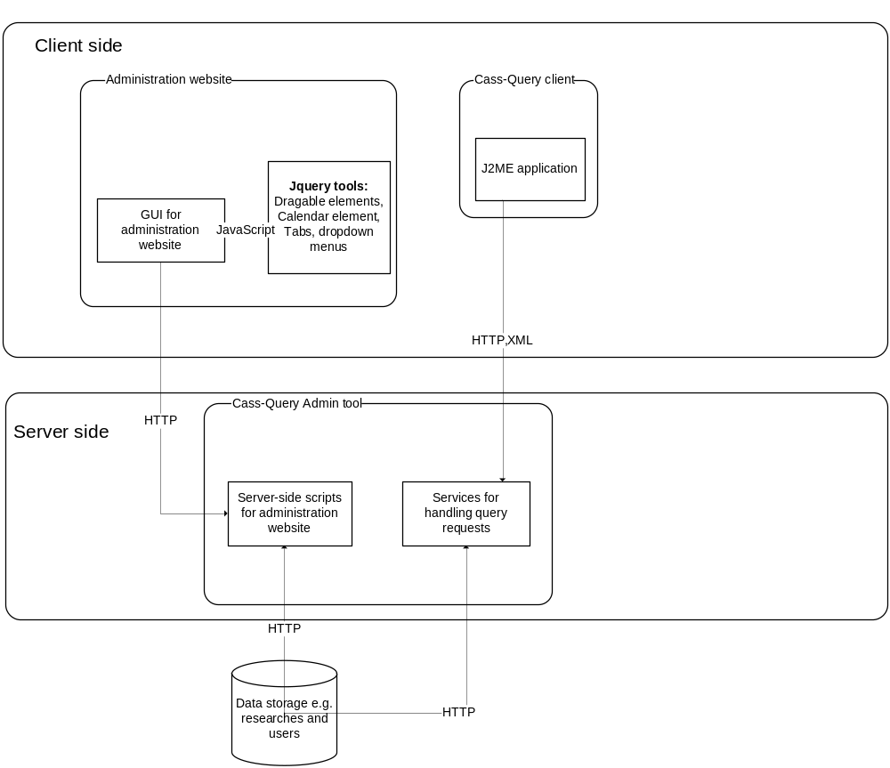
Figure 1: The Cass-Query Architecture

Cass admin GUI
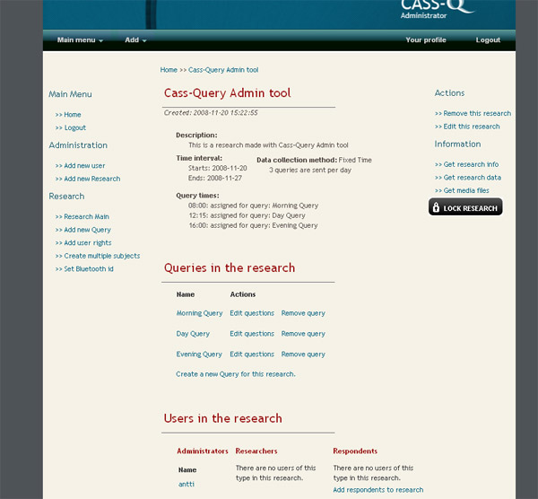
Picure 1: Picture of Cass-Query user interface..

Cass-Query administrator website is a basic HTML-page with Ajax-functionality. For Ajax-functionality is used JQuery-JavaScript classes and basic JavaScript. In Picture 1 is shown the design of the website.

Administration websites HTML is generated from PHP-scripts and mixed with JavaScript-functionality to make it more dynamic. The user interface is kept simple and light to use. Functionality comes over design. Design is made with CSS-stylesheets so it is easily edited.

The website uses sessions to keep track of authentication. It also uses roles, so navigating in website is restricted.

Front end services
- The web service interface is described in detail.
- If applicable, the relation of the front-end service to the ontologies is described. The document will describe how the front-end service is related to the common KP-Lab ontologies (such as the TLO and ROAC), to any other common ontologies (such as the SKOS and FOAF) as well as to the application specific ontologies (such as the shared space application ontology and the change laboratory tool ontology).
- If applicable, the platform services that the front-end service uses are listed. Their usage is briefly described.
- If data is persisted in other databases than the SWKM, the database schemas are described.
- Sequence diagrams and/or class diagrams if considered helpful?

Collaboration with other tools
<Description how the tool interoperates with other tools, on user-interface level, service-level or data-level>.

References
1 Cass-Query Roadmap. (WWW-document) <http://www.kp-lab.org/intranet/design-teams/wk-mobile-tools/Cass-tools roadmap130907.doc> Read 20.11.2008.
2 Cass-Query project. (WWW-document) <http://www.kp-lab.org/intranet/work-packages/WP11/kp-lab-tools/cass-tool/> Read 20.11.2008.

